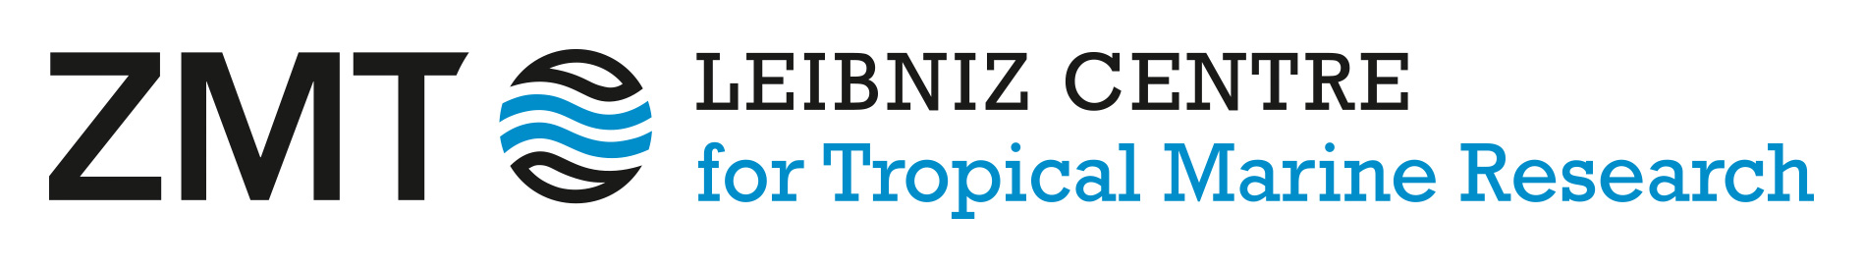

Financial Transfer Requirements
We are delighted that you are interested in joining the Leibniz Centre for Tropical Marine Research (ZMT) as a guest researcher. As part of the financial logistics required for the TropEcS exchange at ZMT in Bremen, Germany, a Wise (formerly TransferWise) account should be established to facilitate the smooth, cost-effective transfer of allowances (if no other European Bank Account is already available).
Reasons for utilizing Wise:
- EU-Registered and regulated Institution: Wise is operated by Wise Europe SA, an institution incorporated in Belgium and strictly regulated by the National Bank of Belgium. This ensures full compliance with European Union financial frameworks.
- Native Euro (EUR) Banking Details: The account provides a fully functional European IBAN (International Bank Account Number). This allows ZMT to disburse funding seamlessly via a standard domestic SEPA (Single Euro Payments Area) transfer, entirely avoiding the heavy delays, high intermediary fees, and tracking issues associated with international wire transfers.
- Mitigation of Local Currency Volatility: Receiving the funding directly into a Euro-denominated balance safeguards the funds from immediate, unfavorable exchange rates or local banking restrictions in tropical home regions, ensuring the stipend maintains its intended value for living expenses in Germany.
1. Step-by-Step Guide to open an Account
1) Sign Up and Register
Go to the Wise website or download the Wise app. Register using a personal email address, choose a secure password, and select your actual country of residence.
2) Select Account Type
Important distinction: Choose a Personal Account. When asked what you want to do first, select the option to "Open a balance" and choose Euro (EUR) as your primary currency.
3) Complete Identity Verification
Required by EU law: To comply with European financial regulations, Wise will ask you to verify your identity. You will need to upload a high-quality photo of your Passport or National ID card, and take a quick selfie using your smartphone to verify it is you.

4) Request your EUR Account Details

Generate your IBAN: Once your identity is verified, go to your EUR balance inside the app and click "Get account details". Wise may require a small initial deposit (usually around €20, which remains yours to spend) using a local card or account to activate the numbers.

5) Provide Details to ZMT
Ready for funding: Wise will instantly generate your official European IBAN and BIC/SWIFT code. Copy these details exactly and provide them to the TropEcS/ZMT administrative team as required in your application, so they can process your SEPA funding transfer directly to your digital wallet.
We are very much looking forward to hearing from you and potentially welcoming you to our institute and the city of Bremen. If you have any immediate further questions regarding these procedures, please do not hesitate to reach out.

Best regards,
The Exchange Coordinator
On behalf of ZMT

Leibniz Centre  for Tropical Marine Research (ZMT)  Sitz der Gesellschaft: Bremen  Fahrenheitstraße 6  28359 Bremen  Deutschland  Telefon: +49 (0) 421 238 00-0  Fax: +49 (0) 421 238 00-30  www.leibniz-zmt.de | Registergericht: Amtsgericht Bremen  Handelsregister Nr.: HRB 25746 HB  Steuer-Nr.: 460/145/09737  USt.-IdNr.: DE 266278207  Vorsitzender des Aufsichtsrates:  Kay Wenzel  Geschäftsführung:  Prof. Dr. Raimund Bleischwitz  Dr. Nicolas Dittert | Bankverbindung:  Sparkasse Bremen  BLZ: 290 501 01  Konto Nr.: 104 7109  IBAN: DE24 2905 0101 0001 0471 09  BIC: SBREDE22

